Thank you for choosing IoT. Follow these steps to launch and use IoT successfully.

**Part 0: Credential Information**

This information is vital to login to IoT.

User: HTR USER

Password: HTR PASSWORD

**Part 1: Installation**

Step 1: Reconfigure Icons and Images

a. Unzip Source_Code.zip

b. Open the src folder.

c. Open Main.java with any editor (Notepad works as well).

d. Change the full paths of the files at the top of the code to the full paths of those exact files in your system. Do not change the name of the files themselves.

Ex: From “C:\\Users\\...\\error.png” to “C:\\Users\\your_user_name\\Downloads\\...\\error.png”, assuming this is the correct path.

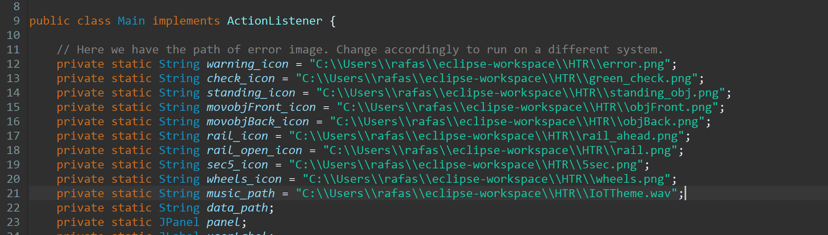

Step 2: Launch CMD in Windows 10 and go to IoT Source Folder

a. Launch CMD if you are in Windows 10.

b. Type:

1. cd <The Full Path of Main.java inside the source folder>

2. javac Main.java

Step 3: Launch IoT

a. To launch IoT, simply type in the command prompt:

java Main.java [Insert here the path of the full path of the sensors text files where data will be read from. Test1.txt is an example of a sensor text file found inside this folder]

**Part 2: How to change the data coming from the sensors?**

Sensor Data is read from a text file fed to the program.

This table summarizes what each number in those text files mean.

|  |  |  |  |  |  |  |
| --- | --- | --- | --- | --- | --- | --- |
| Distance of Standing Object Ahead | Speed of Moving Object Ahead | Current Cargo of the Train |  |  |  |  |
| Distance of Standing Object Ahead | Speed of Moving Object Ahead | Speed of Moving Object Behind | Distance to nearest Railroad Crossing | Functioning Status for Railroad Crossing (0 or 1) | Average Speed of the train | Rotations Per Minute of the Wheels |
| Distance of Standing Object Ahead | Speed of Moving Object Ahead | Speed of Moving Object Behind | Distance to nearest Railroad Crossing | Functioning Status for Railroad Crossing (0 or 1) | Average Speed of the train | Rotations Per Minute of the Wheels |

…

**Thank you for choosing HTR IoT!**